Metal Turning Operations

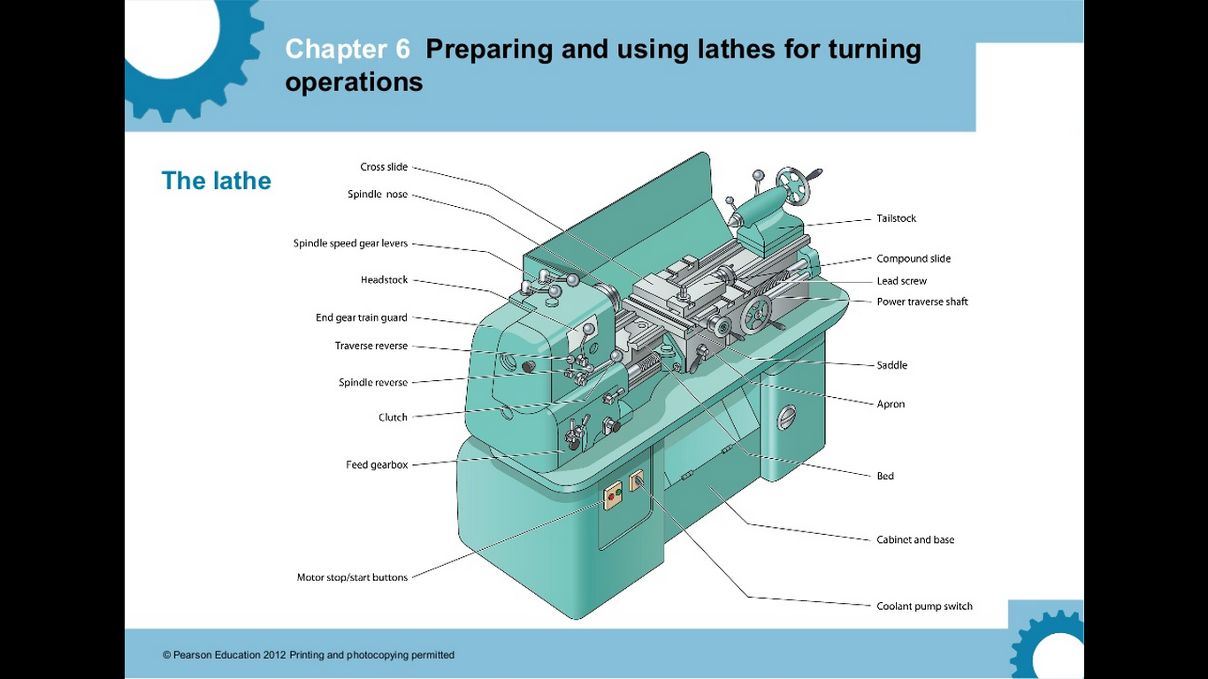

Set Up
Before turning your project, there are a few steps that need to be taken first.
- Ensure correct PPE is worn at all times: face shield, long hair tied back, no loose clothing or jewellery and enclosed leather shoes.
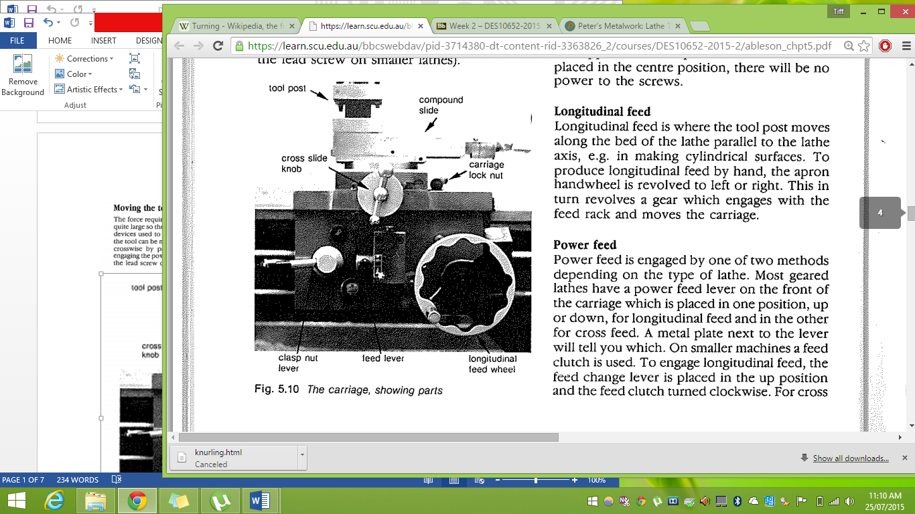
- Check that the lathe is in working order, all parts are running smoothly and there is nothing loose.
- Ensure the chuck key is not in the chuck, turn the lathe on to check if it is running smoothly then turn off and switch off at power point to prevent accidents during the set up stage.
- Insert your job into the chuck and tighten making sure all jaws are clamped evenly on the job. As you tighten the chuck, rotate your job with your hands to help centre the piece, giving better alignment along the axis meaning it will be less wobbly when the lathe is turned on (macarina, 2015).
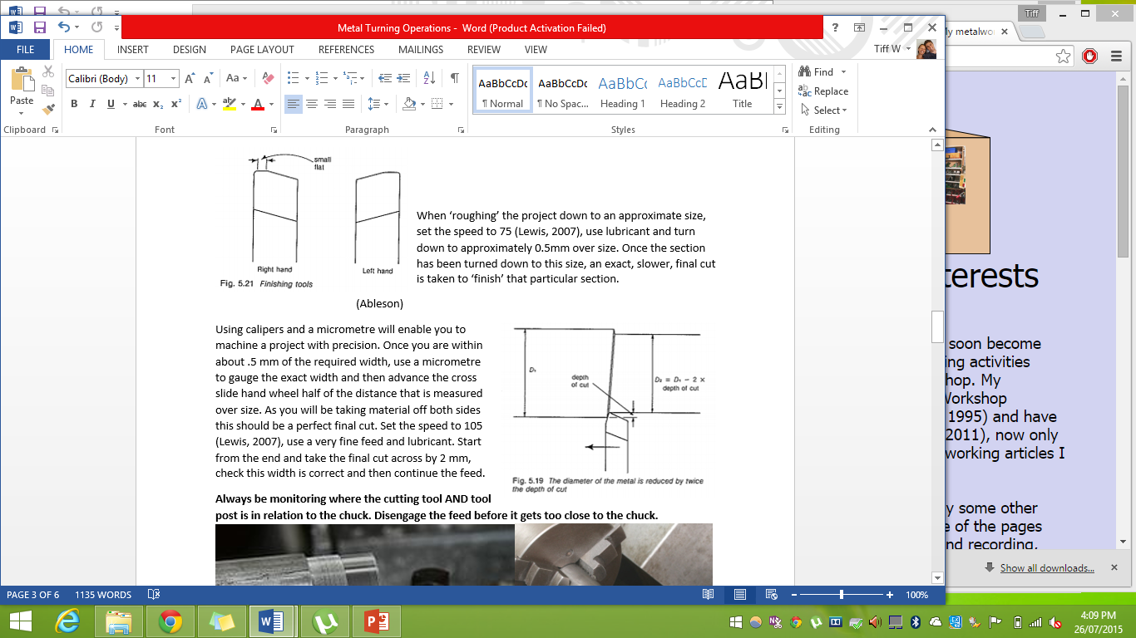
- Tighten the chuck using the key on all teeth if possible, this will ensure that all teeth have the strongest grip on the work piece.
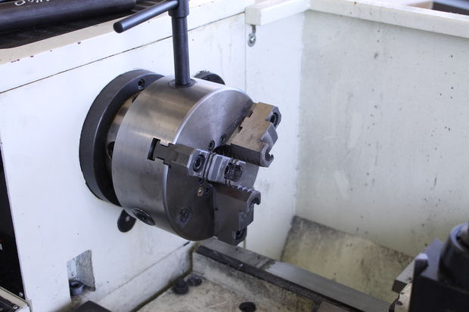
- Install the cutting bit you want to use by lightly clamping it into the tool post so that the cutting edge is as close to the tool post as possible, providing maximum support and minimising the vibration and risk factors.
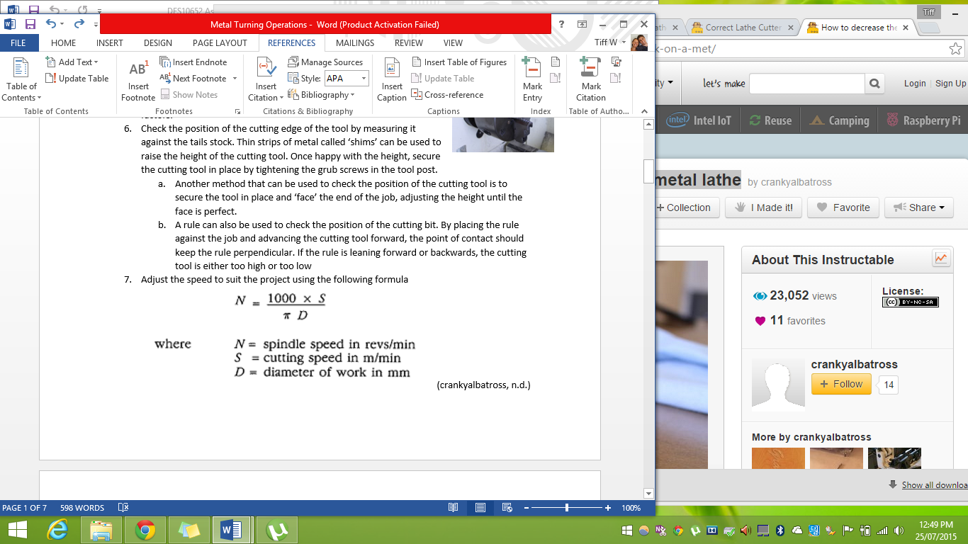
- Check the position of the cutting edge of the tool by measuring it against the tails stock. Thin strips of metal called ‘shims’ can be used to raise the height of the cutting tool. It is important to get the height of the cutting tool at the centre of the job so that the cutting tip is working at maximum efficiency and vibration is reduced. Once happy with the height, secure the cutting tool in place by tightening the grub screws in the tool post.
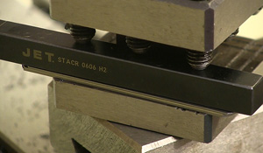
  - Another method that can be used to check the position of the cutting tool is to secure the tool in place and ‘face’ the end of the job, adjusting the height until the face is perfect.
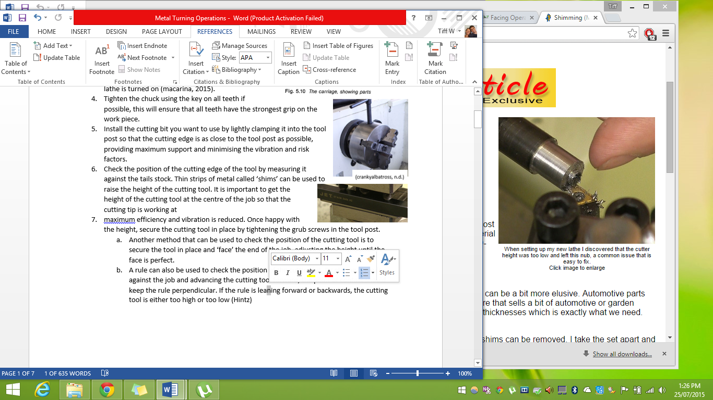
  - A rule can also be used to check the position of the cutting bit. By placing the rule against the job and advancing the cutting tool forward, the point of contact should keep the rule perpendicular. If the rule is leaning forward or backwards, the cutting tool is either too high or too low (macarina, 2015).
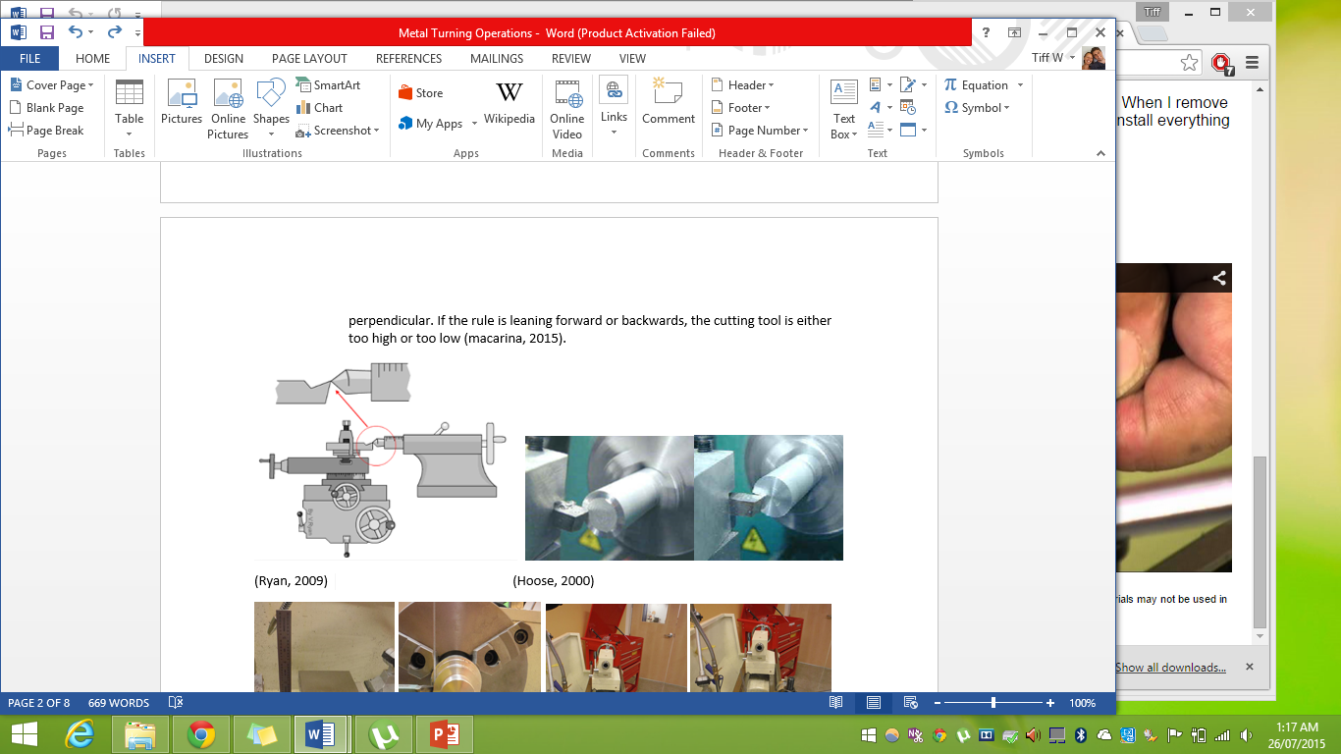
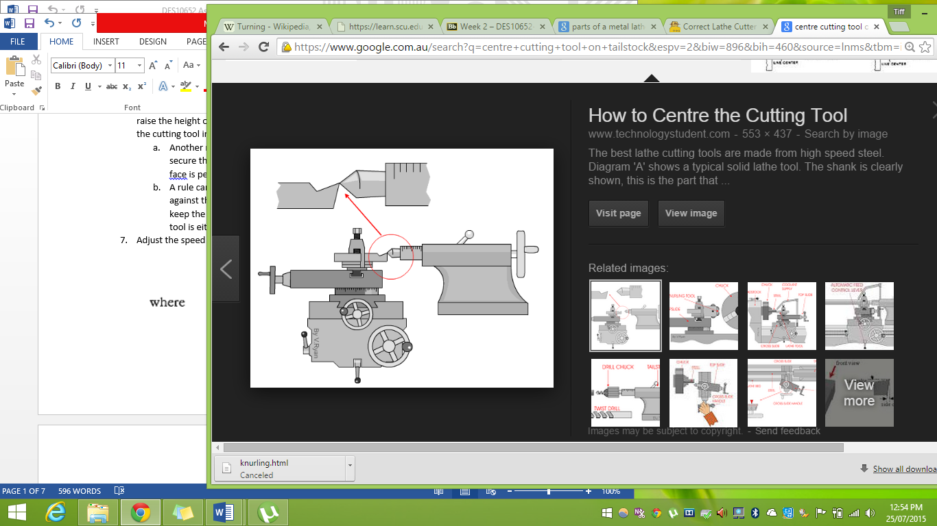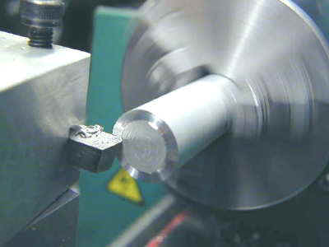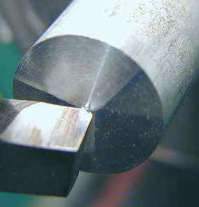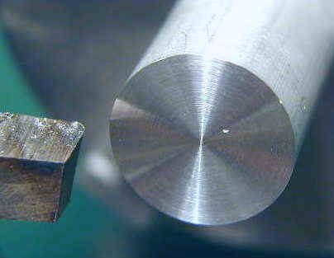
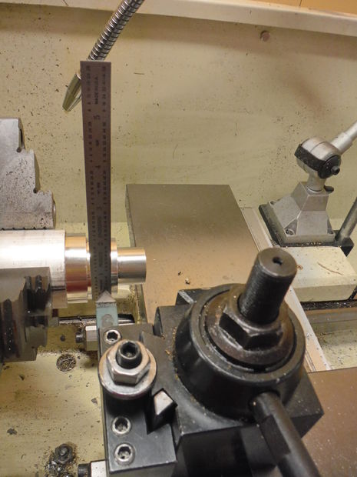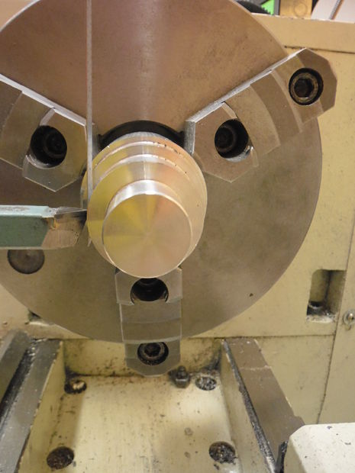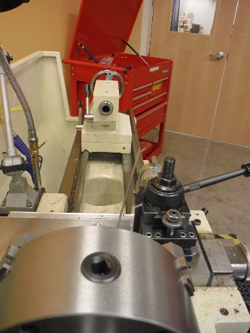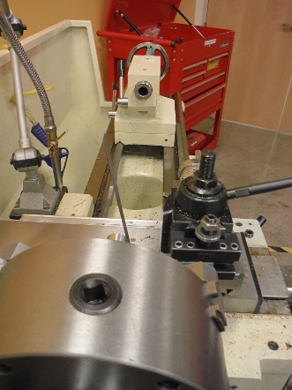
(macarina, 2015)
- Adjust the speed to suit the project using the following formula
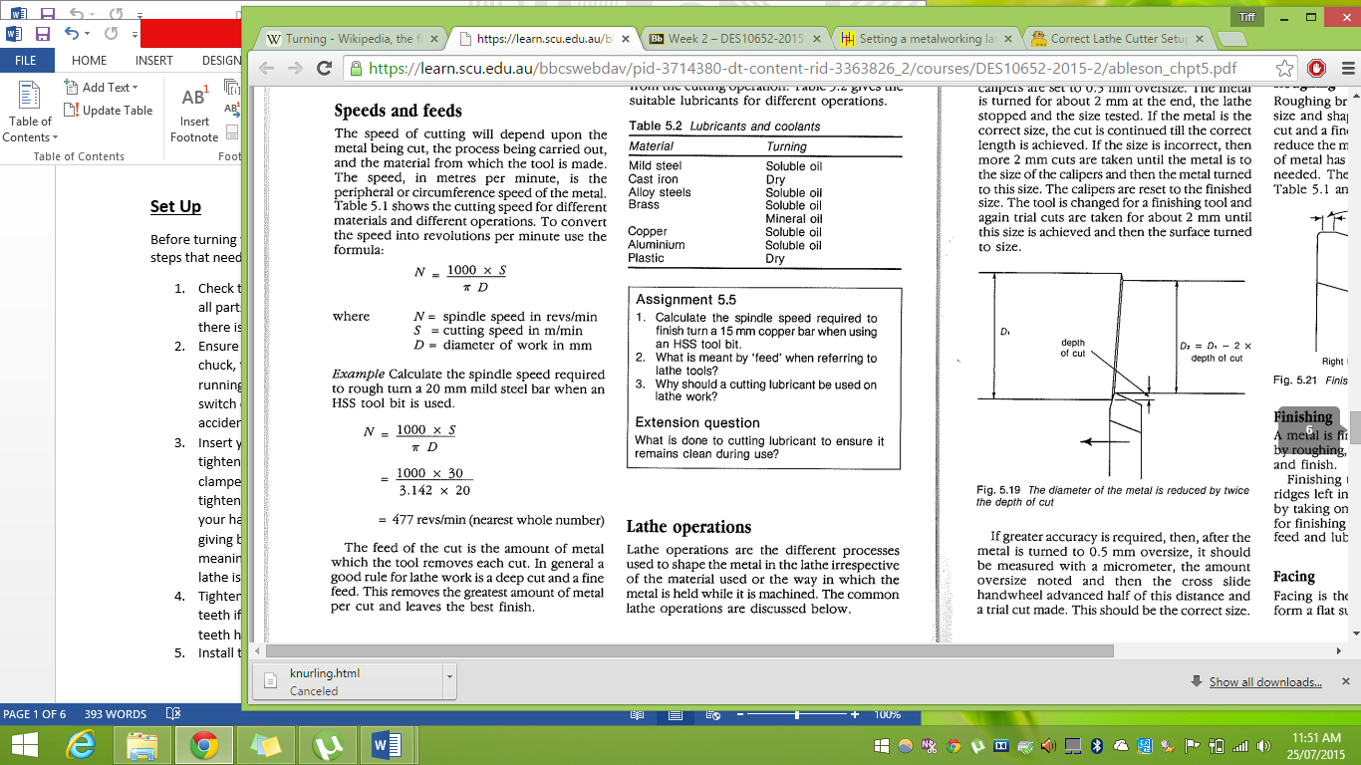
- Source the correct lubricant for the job using the following table. Lubricants are important as they keep the tool cool, prevent friction, wash away swarf, give a good finiah and make the tool last longer.
- You are now ready to start operating the lathe.
Parallel turning
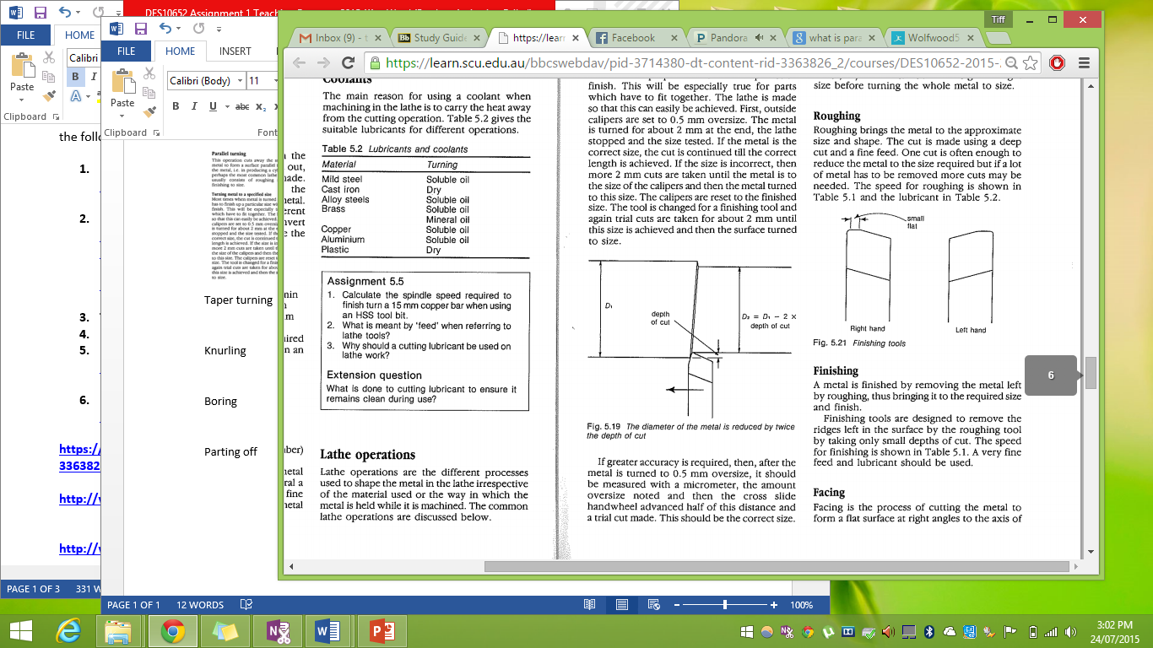
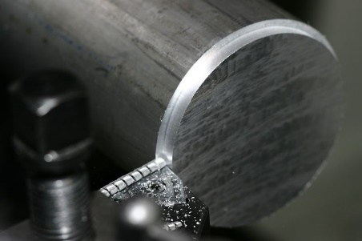
Parallel turning cuts along the surface of the metal parallel to the axis in a horizontal direction. The cutting bit is incrementally moved forward and then fed along the bed to remove metal from the project. This process is known as ‘roughing’. The feed lever may be used to move the tool automatically along the bed at a smooth and consistent rate. Always be monitoring where the cutting tool AND tool post is in relation to the chuck. Disengage the feed before it gets too close to the chuck. (Schott)
When ‘roughing’ the project down to an approximate size, set the speed to 75 (Lewis, 2007), use lubricant and turn down to approximately 0.5mm over size. Once the section has been turned down to this size, an exact, slower, final cut is taken to ‘finish’ that particular section.
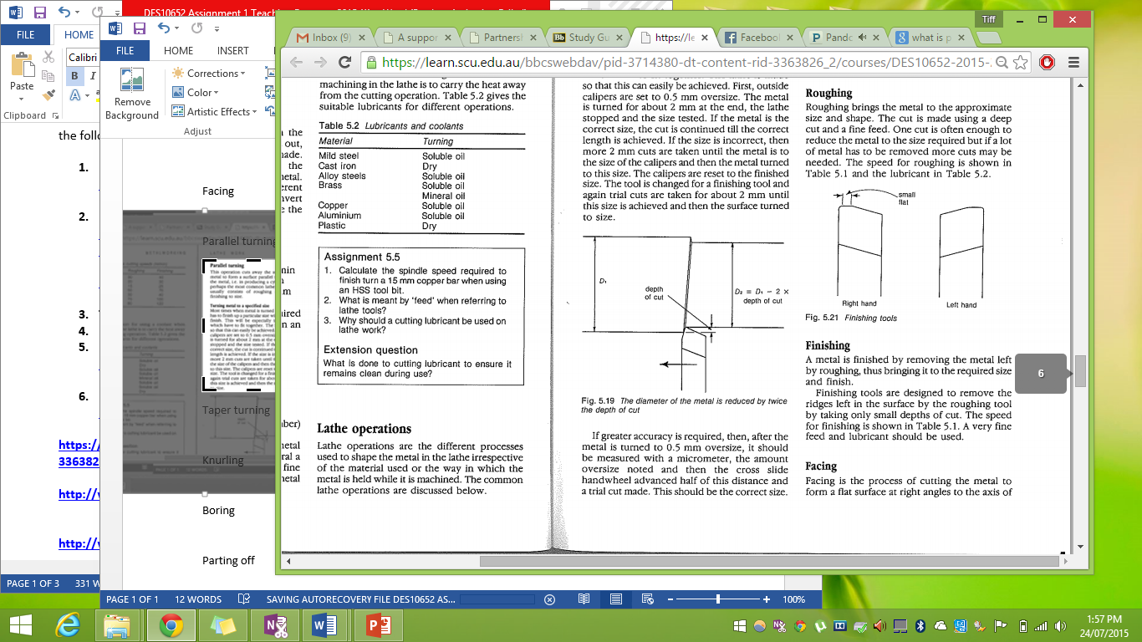
Using calipers and a micrometre will enable you to machine a project with precision. Once you are within about .5 mm of the required width, use a micrometre to gauge the exact width and then advance the cross slide hand wheel half of the distance that is measured over size. As you will be taking material off both sides this should be a perfect final cut. Set the speed to 105 (Lewis, 2007), use a very fine feed and lubricant. Start from the end and take the final cut across by 2 mm, check this width is correct and then continue the feed.
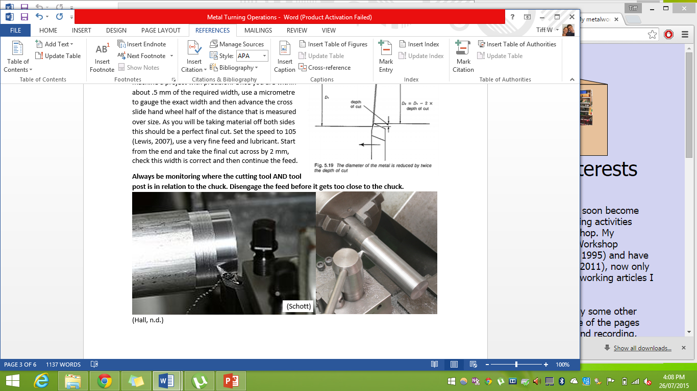
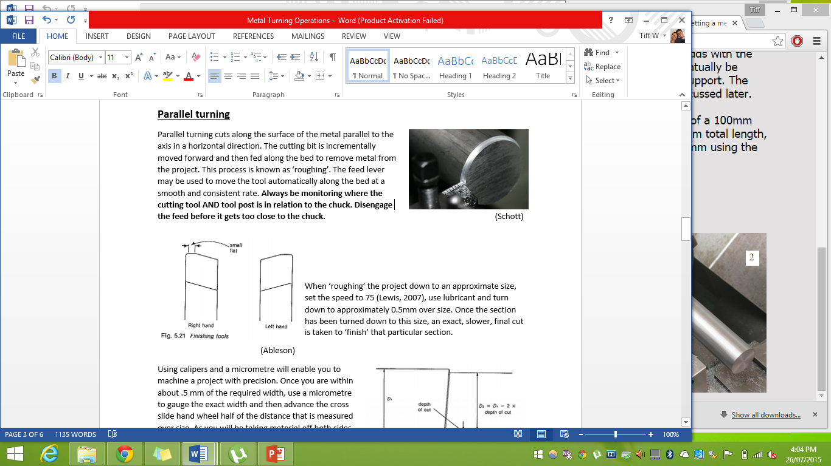
Always be monitoring where the cutting tool AND tool post is in relation to the chuck. Disengage the feed before it gets too close to the chuck. 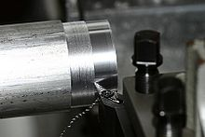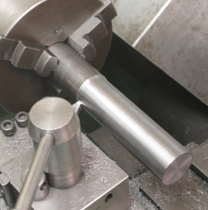
Facing off
Facing off is the process of creating a flat perfect surface on the face end of the project. Due to the considerable forces involved in lathe work, when facing off, the project should be as close to the jaws of the chuck as possible and not protrude more than 2-3 times the size of its diameter.
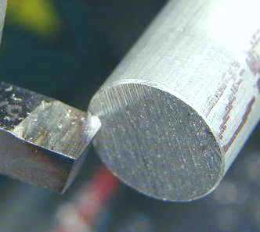
When setting up to face off:
- The cutting tool you choose should have a slightly rounded tip as this will create a smoother finish.
- Ensure correct PPE is worn and lathe is in working order and has been set up at the correct height for the cutting tool you are using and speed for the size and type of material you are turning.
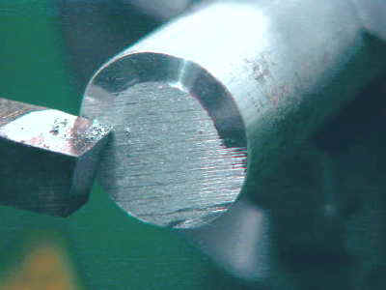
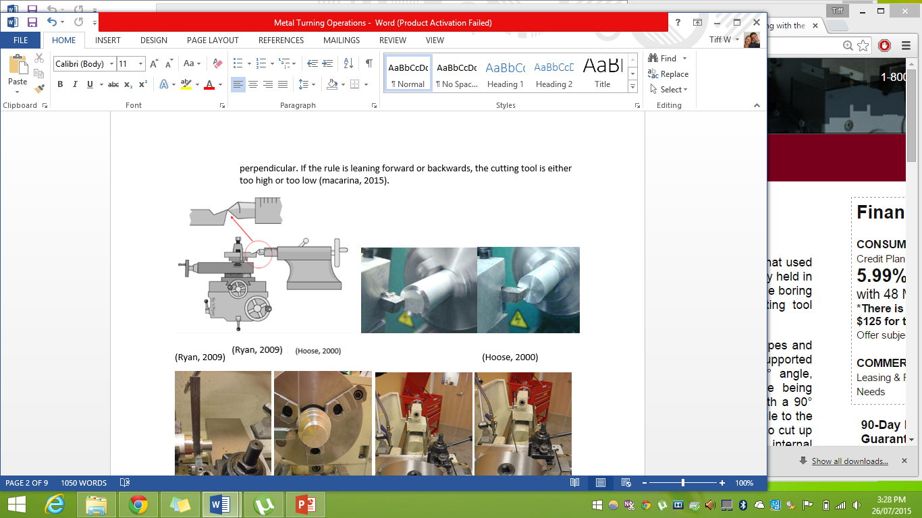
- Clamp the project into the chuck jaws and tighten each jaw individually if possible to ensure even grip. Remember to clamp the project so the face is as close to the jaws as possible without being too close.
- Remove chuck key.
- Slightly rotate the tool carriage so the cutting edge is approximately 5 degrees to the face of the project.
- Set the tumbler gear leaver to neutral and lock the carriage in place to prevent it from sliding back from the force of cutting (Hoose, facing operation, 2000)
- Set the compound slide parallel to the axis
- Advance the tool and move across until it is just touching the face edge as shown by the picture. Retract the tool so that when the lathe is turned on, it will not be affected by the tool.
- Turn the lathe on and slowly advance the tool to the centre of the work piece and then back out again.
- Turn the compound crank to move the tool 0.5 mm towards the chuck and slowly advance the cutting tool into the centre of the project.
- The cutting tool will usually pick up some metal on the return cut, to take advantage of this, you can turn the compound crank and take 0.5 mm off on the return cut.
- Once the roughing stage is complete, a final pass can be taken to finish the ‘facing’ process.
  - Increase the speed of the lathe
  - Move the compound crank 0.2mm towards the chuck
  - Slowly advance the cutting tool towards the centre of the project and then slowly retract the tool.
- Turn the lathe off.
Taper turning
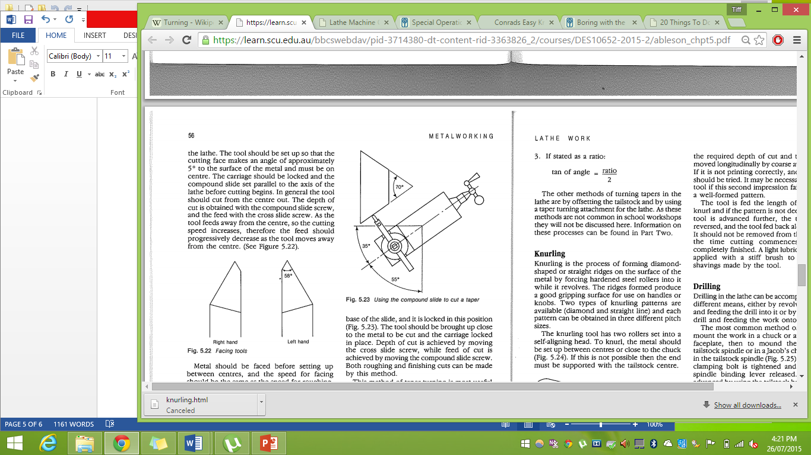
To turn a cone or conical shape, you will need to use ‘taper turning’ which is a process of turning at an angle to the axis of the metal as seen in figure 5.23. Using the compound slide, the pitch of the taper can be easily set however the range of the cross slide does limit the length of taper that can be achieved.
There are four ways to express taper turning.
- As the included angle of the taper
- As a taper in millimetres per metre (mm/m)
- As the diameter at each end of the taper and the length of the taper
- As a ratio. (Ableson)
To turn a taper using the ‘compound slide’ method, first you will need to set the agle for the taper you require. To do this you will need to know the dimensions for both ends of the taper (D & d) and the length of the taper (L). You will then need to use the following formula to calculate the angle.
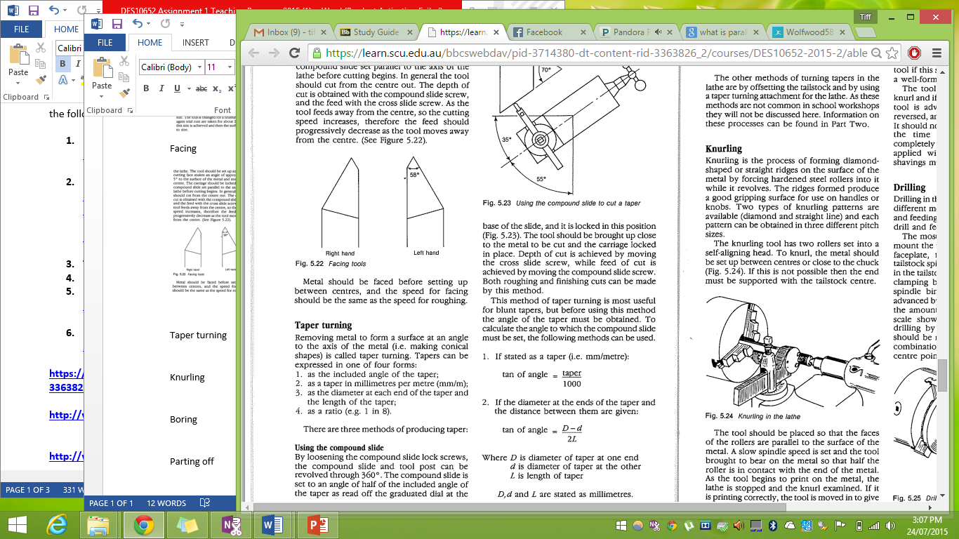
Once you have determined the measurements, you will be able to calculate the required angle. The diagram below shows an example of the process.
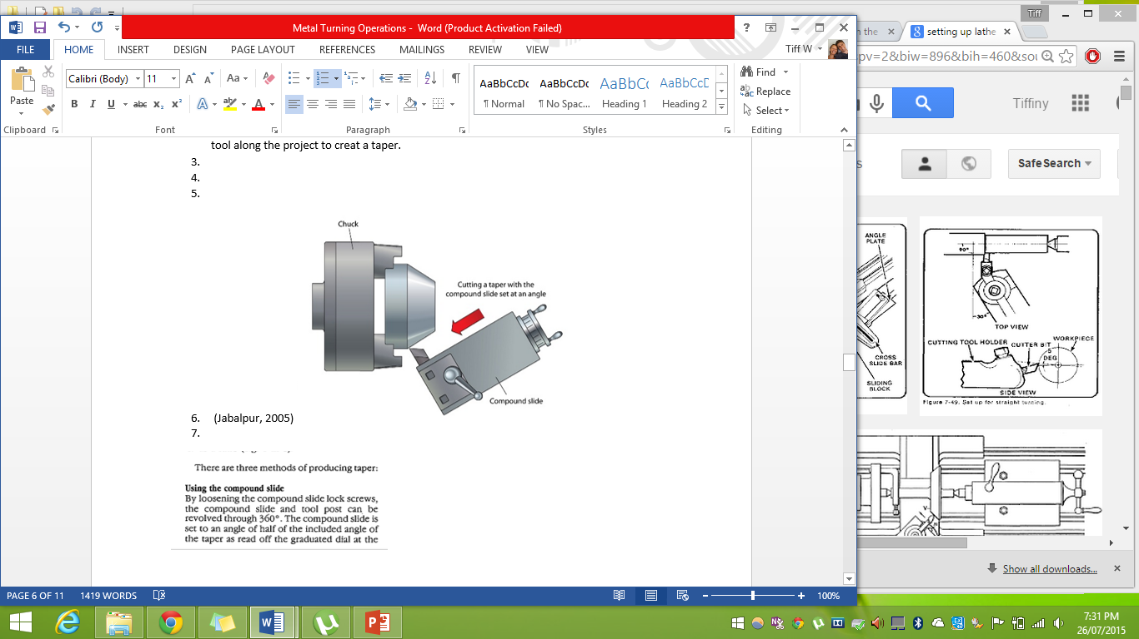
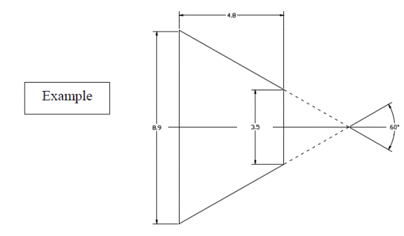
Once you have calculated the angle you can start the turning process.
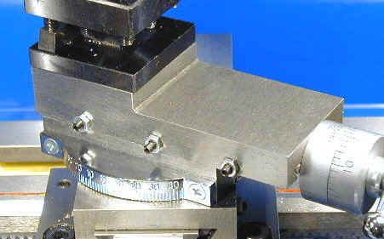
- Ensure correct PPE is worn and lathe is in working order and has been set up at the correct height for the cutting tool you are using and speed for the size and type of material you are turning.
- Clamp the project into the chuck jaws and tighten each jaw individually if possible to ensure even grip. Remember to clamp the project as close to the jaws as possible without being too close.
- Remove chuck key.
- Face off the end of the project.
- Loosen the compound slide lock screws and rotate the compound slide around. There is a graduated dial at the base, you will need to set the angle to half of the taper angle you require and then lock the base in that position.
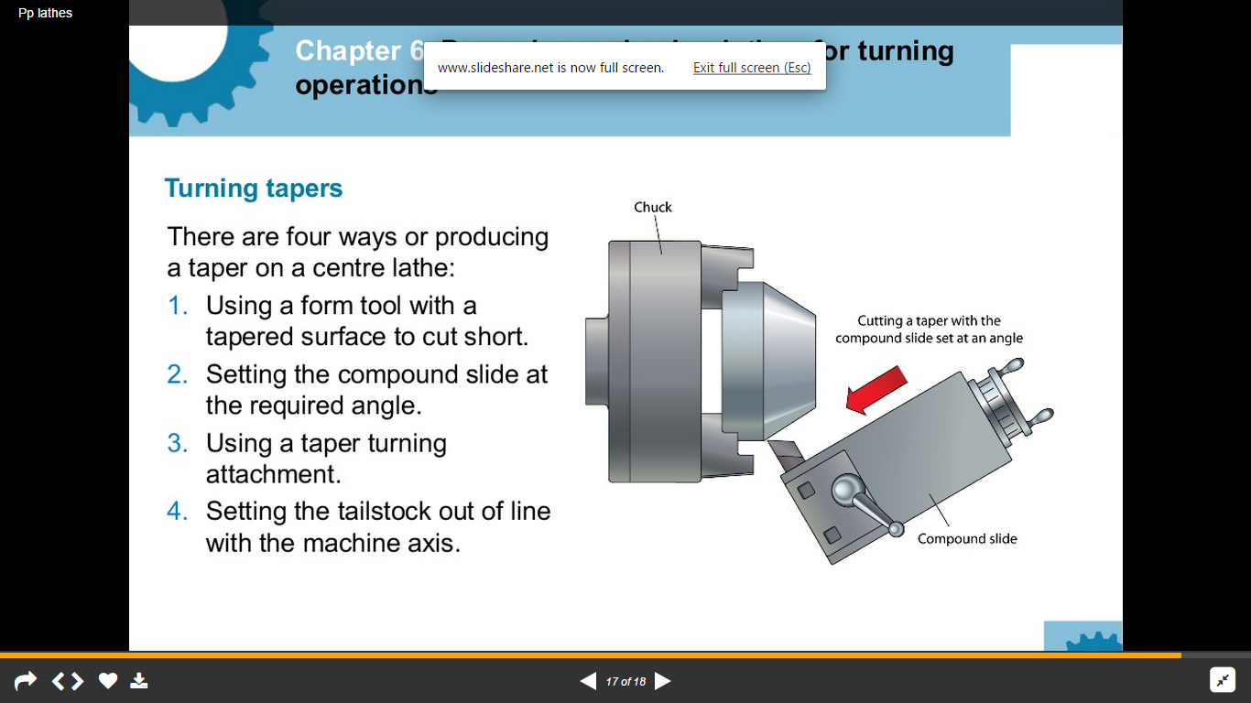
- Once you have set the compound slide, you can use the compound slide screw to move the cutting tool along the project to creat a taper.
- Use appropriate lubricant for the material (see table 5.2 lubricants and coolants) Start by taking a small taper off the corner and then advance the cutting tool incrementally untill the taper extends almost to the required length (L) which should also produce the required diameter (d) on the face end.
- Increase the speed of the lathe and take one final pass to finish off the tapering process.

Knurling
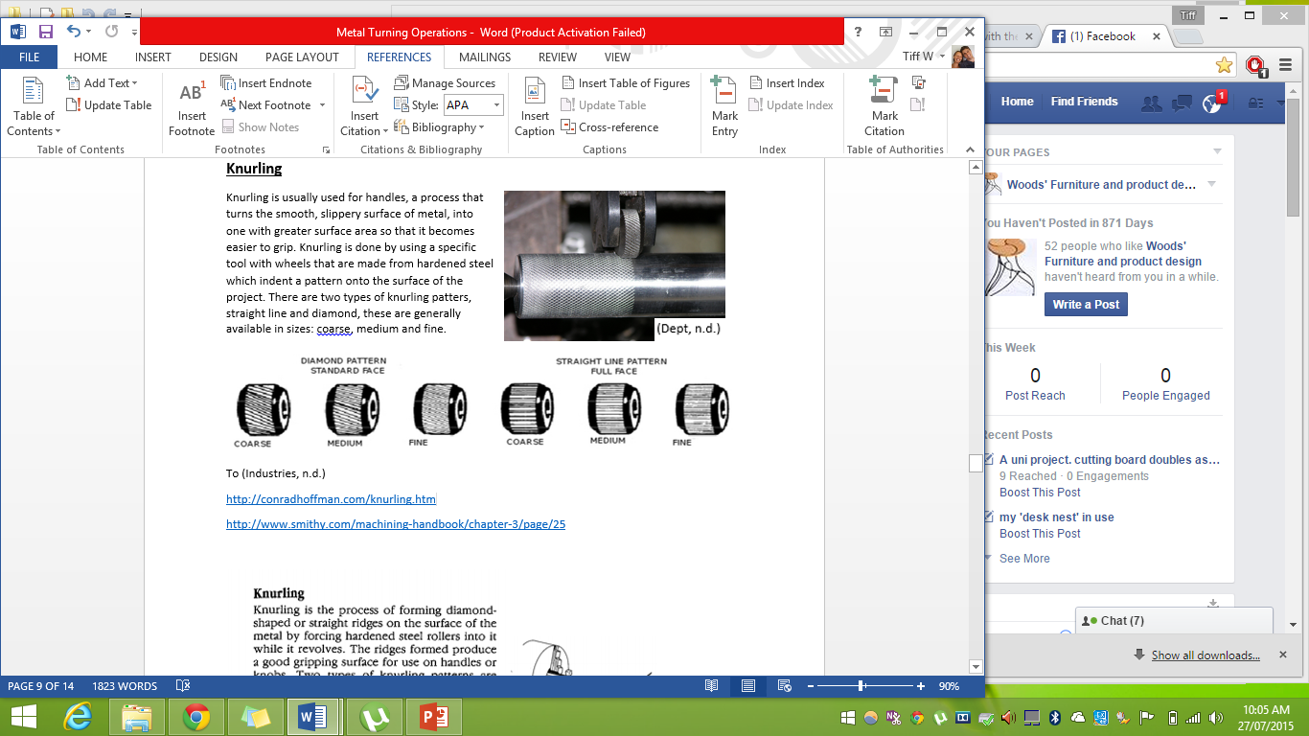
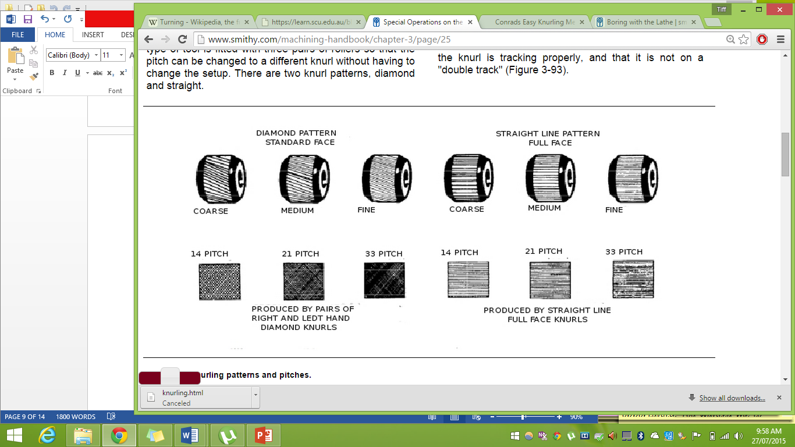
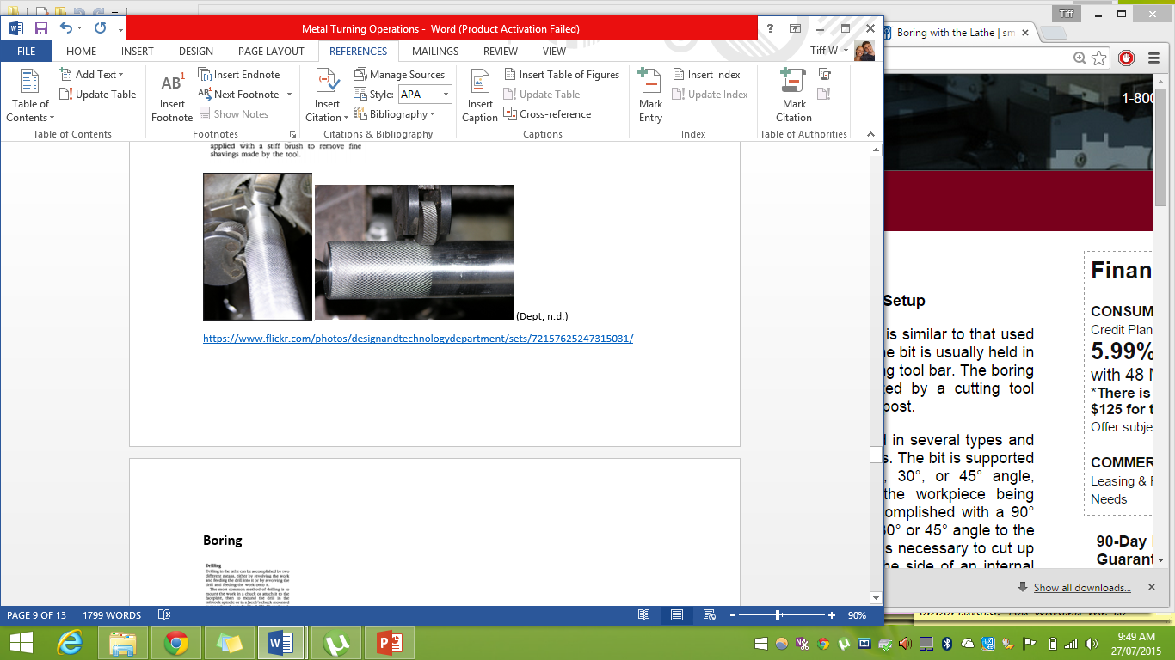
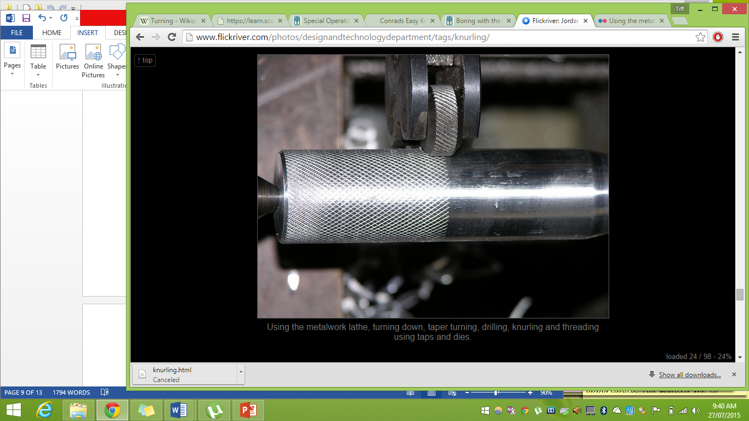
Knurling is usually used for handles, a process that turns the smooth, slippery surface of metal, into one with greater surface area so that it becomes easier to grip. Knurling is done by using a specific tool with wheels that are made from hardened steel which indent a pattern onto the surface of the project. There are two types of knurling patters, straight line and diamond, these are generally available in sizes: coarse, medium and fine.

To set the lathe up for knurling, you first need to select the pattern and size. Most operations will require the medium grade unless the project is very large or small. Once you have your knurl, you are ready to start.
- Ensure correct PPE is worn and lathe is in working order and has been set up at the correct height for the cutting tool you are using and speed for the size and type of material you are turning.
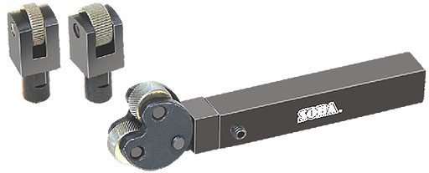
- Clamp the project into the chuck jaws and tighten each jaw individually if possible to ensure even grip. Remember to clamp the project as close to the jaws as possible without being too close.
- Remove chuck key.
- Face off the end of the project.
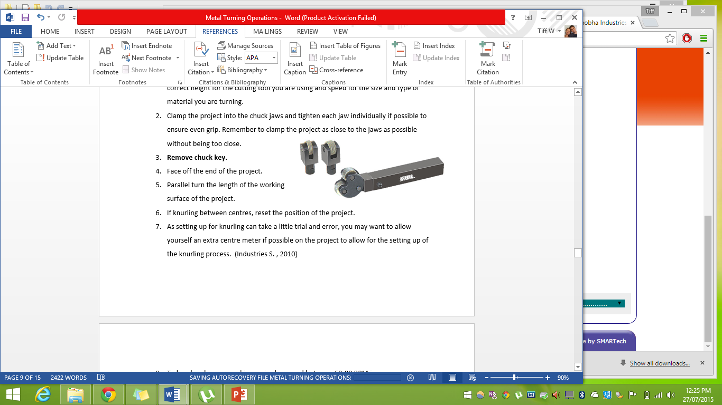
- Parallel turn the length of the working surface of the project.
- If knurling between centres, reset the position of the project.
- As setting up for knurling can take a little trial and error, you may want to allow yourself an extra centre meter if possible on the project to allow for the setting up of the knurling process.
- To knurl, a slower speed is required, a speed between 60-80 RPM is common practice. Set the speed of the lathe and the feed of the carriage to approximately 0.5mm per revolution of the spindle.
- Check the rollers of the knurling tool are spinning freely and undamaged
- Set up the knurling tool in the tool post so that the axis of the knurling head is at the centre and the faces of the wheels lightly contact the project. If the knurling wheels are set up too close to the project, the knurl will not cut as smoothly and either the project or the tool could get damaged.
- Lubricate the rollers.
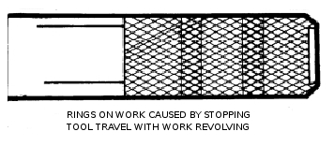
- Start the lathe and advance the knurling rollers ¼ of a millimetre into the project or until an impression starts to form.
- Engage the feed lever and observe for half a centre meter before turning the machine off. This will stop both the chuck and feed from turning at the same time. You should not stop the carriage feed while the tool is still in contact with the project as this will create wear rings on your project.
- Leave the rollers where they are as this will keep them in position, Inspect the project to make sure the pattern is getting imprinted evenly and not ‘double tracking’
- If the tool is double tracing, you will need to reset it, otherwise, take the tool carraige back to the starting point and alighn the rollers into the grooves ready to start.
- Increase the delth of cut by the knurling rollers and start the lathe.
- Engage the feed cut through to the desired length then turn off the lathe.
- Force the tool deeper into the work, reverse the feed and turn the lathe back on. Do not allow the tool to feed off the project as this can damage the project or lathe centres if turning between centres.
- Repeat steps 17 & 18 until the shape fo the knurl has been full developed.
- If you are turning from the chuck only and have allowed for the extra length, part off the end of your project to get it to required length. You may also want to put a slight taper on the end of the project.
Drilling & Boring
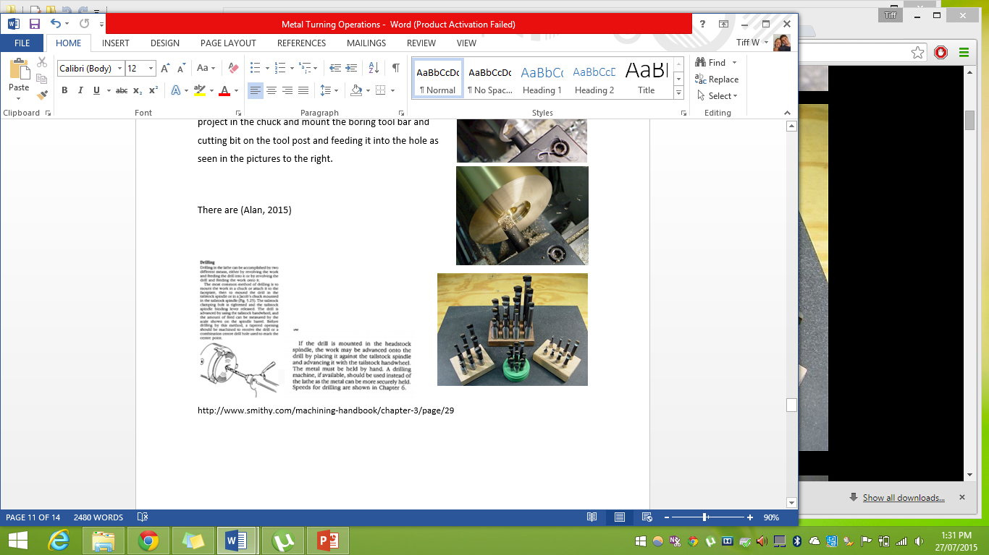
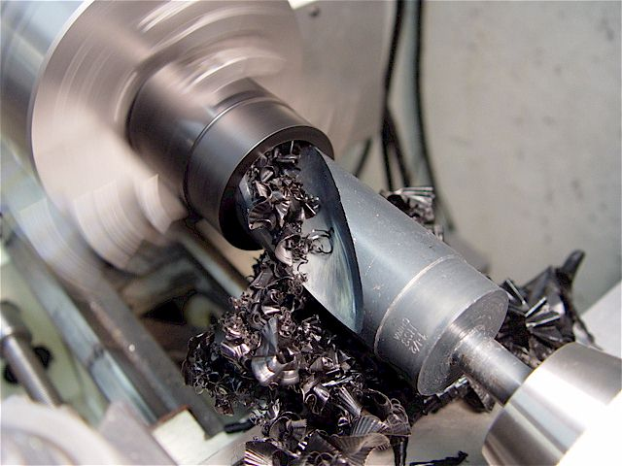
Drilling using the metal lathe is usually accomplished by clamping the project into the chuck, facing it and then using a centre drill bit, set up in the tailstock, to start a centred and accurate hole that will enable a drill bit to successfully bore in further. The centre drill bit is then replaced with the drill bit, ready to bore a hole further into the work piece.
The tailstock will need to be locked in order for the drill to successfully bore a hole. Slowly advance the drill by turning the tailstock wheel. Ensure the drill is well lubricated and swarf is cleared regularly by withdrawing the drill every few millimetres.
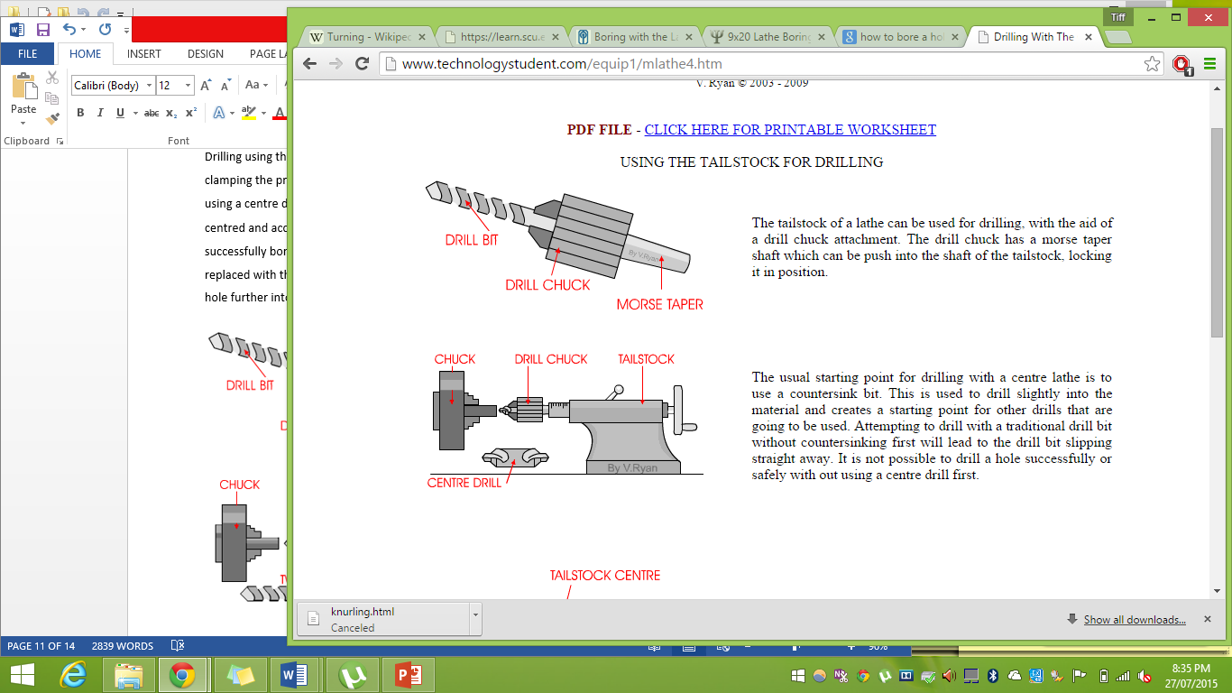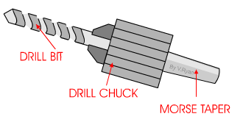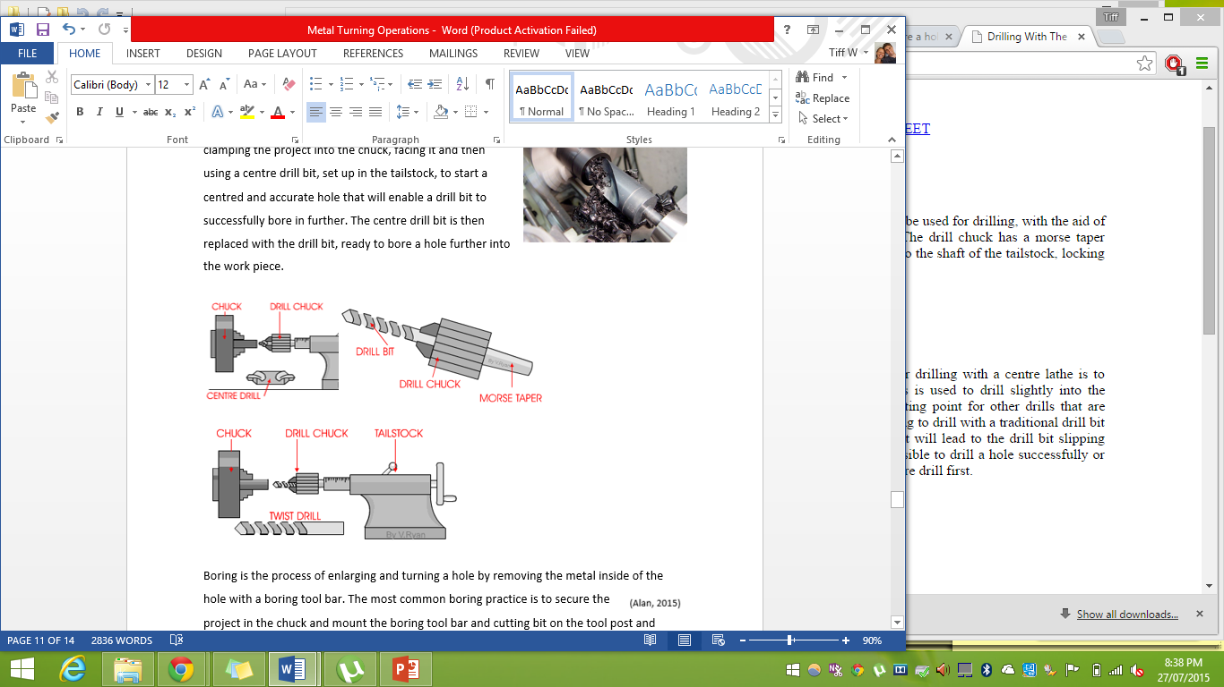
(Ryan, Drilling with the centre lathe , 2003)
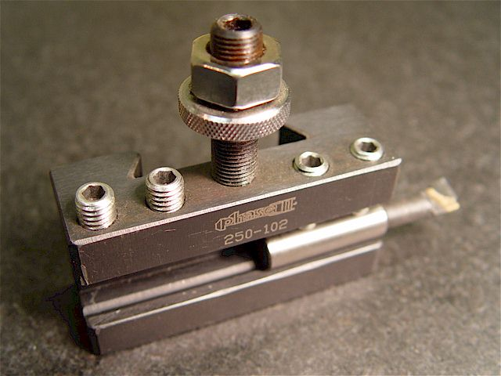
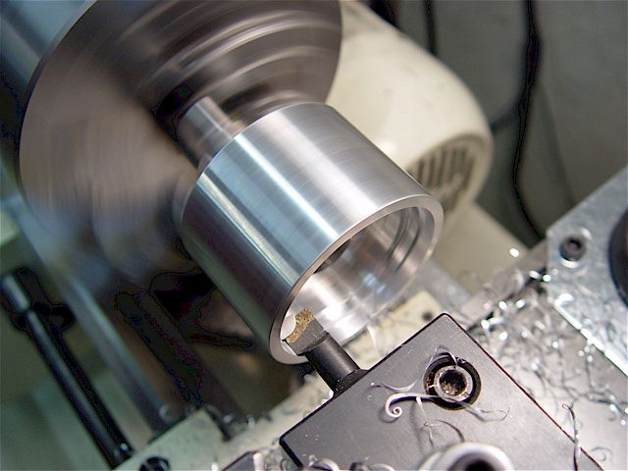
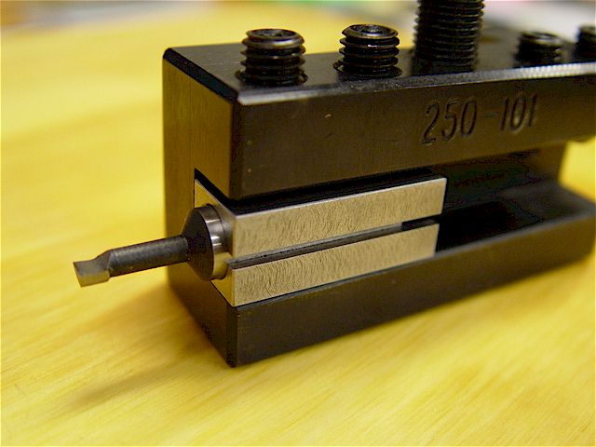
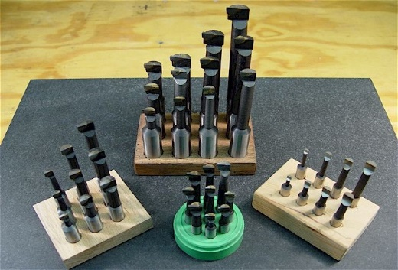
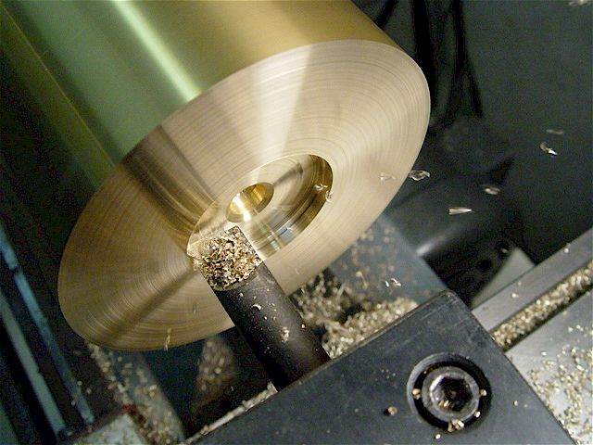
Boring is the process of enlarging and turning a hole by removing the metal inside of the hole with a boring tool bar. The most common boring practice is to secure the project in the chuck and mount the boring tool bar and cutting bit on the tool post and feeding it into the hole as seen in the pictures to the right. There are a number of different types of boring tool bars and methods to hold them in the cutting tool holders. Choose the right tool and method for the job, if you are unsure, ask your teacher first.
- Ensure correct PPE is worn and lathe is in working order and has been set up at the correct height for the cutting tool you are using and speed for the size and type of material you are turning.
- Clamp the project into the chuck jaws and tighten each jaw individually if possible to ensure even grip. Remember to clamp the project as close to the jaws as possible without being too close.
- Remove chuck key.
- Face off the end of the project.
- To set the lathe up for boring, secure the boring bar in the tool post as seen above.
- When setting the height for the cutter, it should be slightly above centre to allow for the slight spring caused by the downward force of the spinning project on the cutting bit.
- The tool bit should be clamped as close to the tool post as possible that the maximum safe depth of cut can still be made. For deeper cuts, use a thicker bar to prevent a ‘springing’ action.
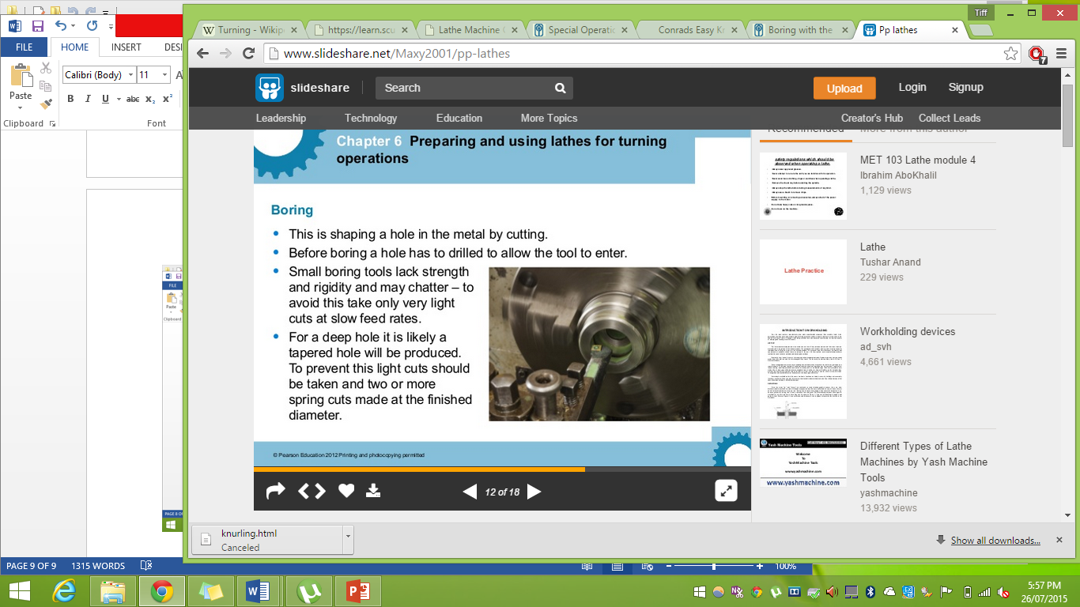
- While the lathe is still turned off, move the cutting bit into the hole to test where the cutting surface reaches and whether the boring tool bar clears the inside of the diameter.
- Set the speed of the lath to the same that would be used for parallel turning.
- The feed and the depth of cut taken should be considerably less than straight turning as there is less rigidity in the set up.

Parting off
You have made something, something great! Congratulations! Now, how do you get it off the lathe? More importantly, how do you separate it from the rest of the metal length? You will need to part it off and that will require a special cutting tool as seen below.
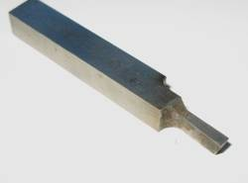 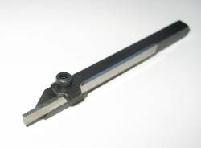 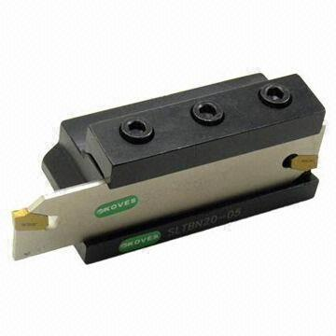 (DiracDelta, n.d.) (Koves, 2015)
Parting off requires a special cutting tool that is shaped specifically for parting metal on a lathe. As can be seen by the diagram below, the view of the tool shows a slight taper on the top and sides with a substantial taper on the cutting edge. This allows the tool to cut efficiently while reducing the chance of friction caused by the build-up of swarf.
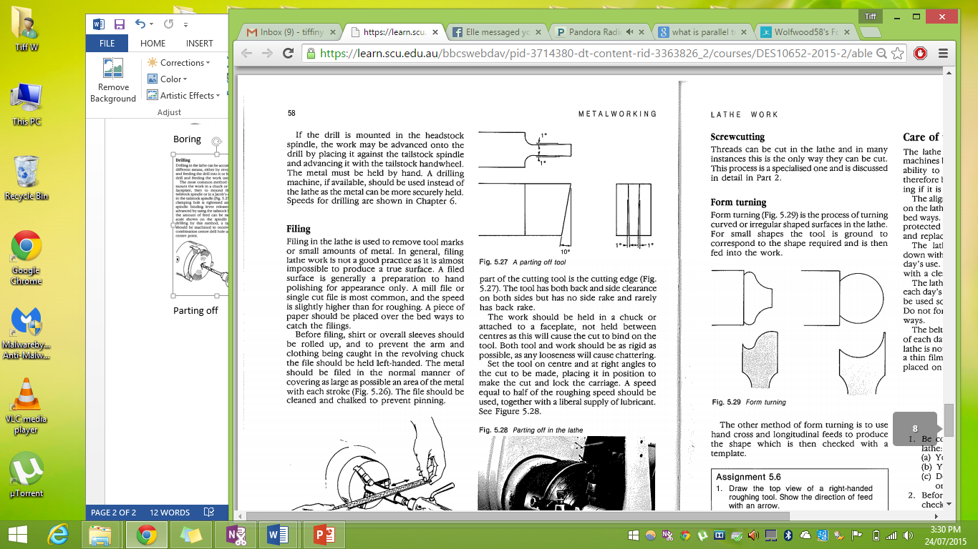
When parting, the work should be held by the chuck or a faceplate but not between centres as this will bind the tool towards the end of the cut. Parting off is the last step in producing a product on the lathe.
- Ensure the cutting tool is sharp and undamaged
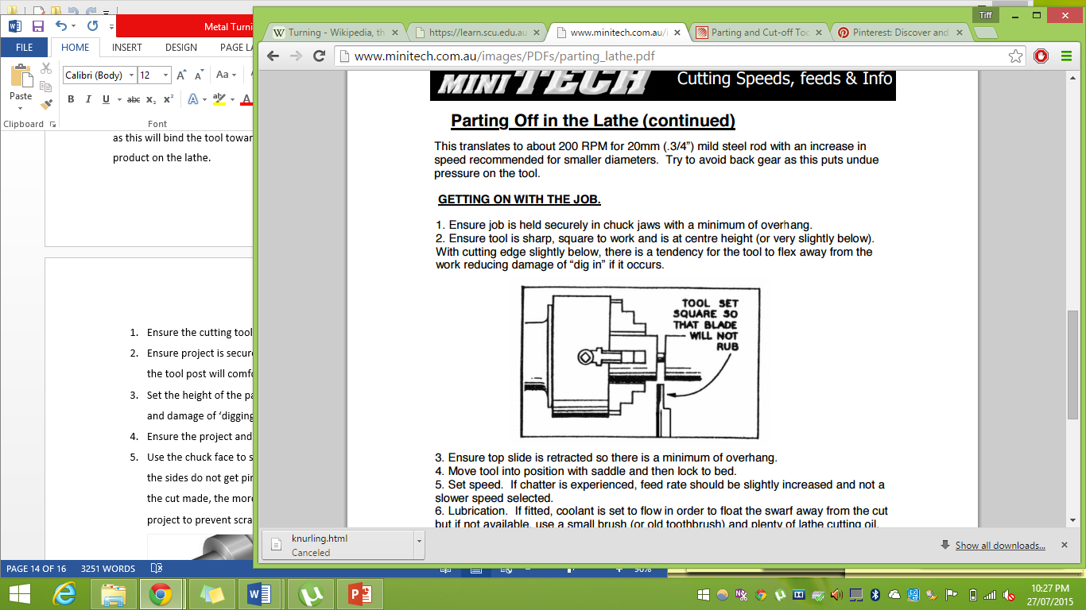
- Ensure project is secure in chuck with the parting off section as close to the chuck as the tool post will comfortably allow. Check this physically and visually.
- Set the height of the parting tool to 0.2 mm below centre, this will reduce the chance and damage of ‘digging in’
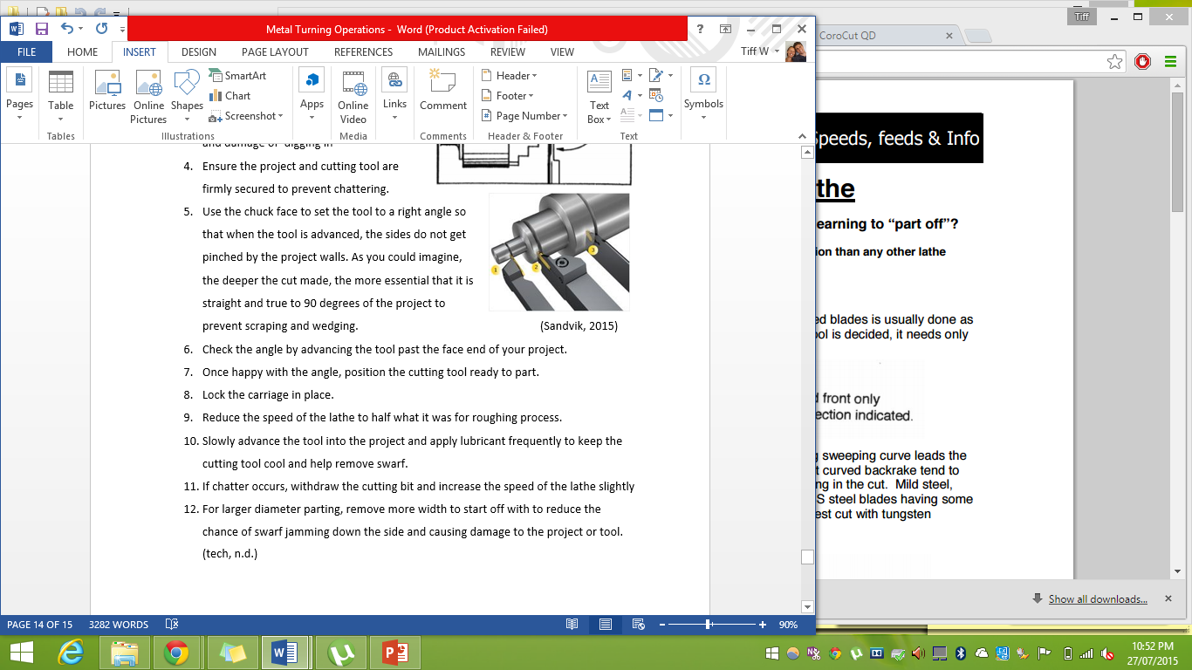
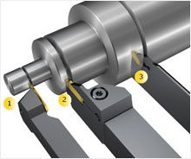
- Ensure the project and cutting tool are firmly secured to prevent chattering.
- Use the chuck face to set the tool to a right angle so that when the tool is advanced, the sides do not get pinched by the project walls. As you could imagine, the deeper the cut made, the more essential that it is straight and true to 90 degrees of the project to prevent scraping and wedging. (Sandvik, 2015)
- Check the angle by advancing the tool past the face end of your project.
- Once happy with the angle, position the cutting tool ready to part.
- Lock the carriage in place.
- Reduce the speed of the lathe to half what it was for roughing process.
- Slowly advance the tool into the project and apply lubricant frequently to keep the cutting tool cool and help remove swarf.
- If chatter occurs, withdraw the cutting bit and increase the speed of the lathe slightly
- For larger diameter parting, remove more width to start off with to reduce the chance of swarf jamming down the side and causing damage to the project or tool. (tech, n.d.)

References
Ableson. (n.d.). 5 Lathe Work. Retrieved from https://learn.scu.edu.au/bbcswebdav/pid-3714380-dt-content-rid-3363826_2/courses/DES10652-2015-2/ableson_chpt5.pdf
Alan. (2015). Lathe Boring Bars. Retrieved from Micro Machine Shop : http://www.micro-machine-shop.com/boring_bars.htm
crankyalbatross. (n.d.). How to decrease the diameter of bar stock on a metal lathe. Retrieved from instructables : http://www.instructables.com/id/How-to-decrease-the-diameter-of-bar-stock-on-a-met/
Dept, J. S. (n.d.). Retrieved from flickriver: http://www.flickriver.com/photos/designandtechnologydepartment/tags/knurling/
DiracDelta. (n.d.). Parting off tool. Retrieved from DiracDelta.co.uk science and engineering encyclopedia: http://www.diracdelta.co.uk/science/source/p/a/parting-off%20tool/source.html#.VbYmf_mqqkp
Education, P. (2012). Preparing and using lathes for turning operations . Retrieved from SlideShare: http://www.slideshare.net/Maxy2001/pp-lathes
Hall, H. (n.d.). Metalwork . Retrieved from Metal working and other interests : http://www.homews.co.uk/page318.html
Hintz, T. (n.d.). Shimming (metal) Lathe Cutter Height. Retrieved from New Metal Worker: http://www.newmetalworker.com/howto/setlahecutrheight.html
Hoose, F. J. (2000). facing operation. Retrieved from mini lathe operation: http://www.mini-lathe.com/Mini_lathe/Operation/Facing/facing.htm
Hoose, F. J. (2000). Mini Lathe Opperation: Facing. Retrieved from minilathe.com: http://www.mini-lathe.com/Mini_lathe/Operation/Facing/facing.htm
Industries, S. (2010). Lathe tools . Retrieved from Shobha Industries : http://www.shobha-india.com/lathe-tools/lathe-tools-d8.html
Industries, S. (n.d.). Special operations on the lathe . Retrieved from Smithy. Small shop solutions : http://www.smithy.com/machining-handbook/chapter-3/page/25
Jabalpur. (2005). 3.1 By swiveling the compound rest . Retrieved from Indian Institute of Information Technology, Design and Manufacturing Jabalpur: http://iiitdmj.ac.in/Vlabs/Manufacturing/Exp2/swiveling.html
Koves, D. (2015). Dongguan Koves Cutting Tools Co. Ltd. Retrieved from Global sources : http://www.globalsources.com/si/AS/Dongguan-Koves/6008841876157/pdtl/Parting-and-Cut-off-Tool-Holder/1052675488.htm
Lewis, P. N. (2007). Lathe Turning Finish. Retrieved from Peters Metalwork : http://www.peter.com.au/metalwork/turning-finish.html
macarina. (2015). Correct Lathe Cutter Setup. Retrieved from Instructables: http://www.instructables.com/id/Correct-Lathe-Cutter-Setup/
Ryan, V. (2003). Drilling with the centre lathe . Retrieved from technology student : http://www.technologystudent.com/equip1/mlathe4.htm
Ryan, V. (2009). How to centre the cutting tool. Retrieved from technology student: http://www.technologystudent.com/equip1/mlathe6.htm
Sandvik. (2015). Sandvik. Retrieved from Corocut QD: http://www.sandvik.coromant.com/en-us/products/corocut-qd/Pages/product-details.aspx?utm_campaign=november2014_enewsletter&utm_source=apsis&utm_medium=email&utm_content=unspecified
Schott, F. (n.d.). SchruppenDrehen. Wikimedia. Retrieved from https://en.wikipedia.org/wiki/Turning#/media/File:SchruppenDrehen.jpg
tech, m. (n.d.). parting off in the lathe . Retrieved from Mini TECH cutting speeds, feed & info: http://www.minitech.com.au/images/PDFs/parting_lathe.pdf

